

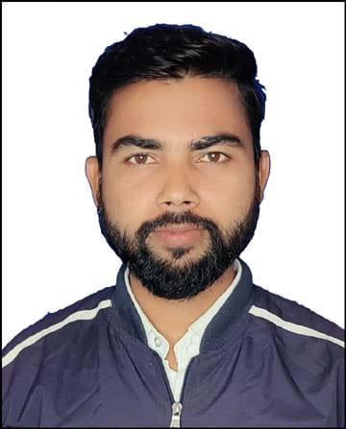

Ref No : TEC/2024/02

**TO WHOM IT MAY CONCERN**

This is to certify that **Mr. Pankaj Kumar Sharma S/O Sri Gulab Chand Sharma** has beenworking in our organization as a **“COMPUTER TEACHER”** from 06th August 2021 to 30th November 2023.Working time is 02:00 – 07:00 PM.

Mr. Pankaj Kumar Sharma was responsible for:-

1) Delivering engaging and interactive computer lesson to

students.

2) Preparing lesson plan, study materials and conducting

assessments.

3) Guiding students in practical programming and IT application.

He is hardworking, dedicated and reliable professional with excellent communication and technical skill. His ability to connect with students and simplify complex topic has been commendable.

We are confident that he will excel in his future endeavors and contribute significantly to any organization he joins.

We wish him all the best in his future career.

For THE EUROPEAN Date :- 05-12-2023